www.RoyalLePageThompson.ca
Facebook – RoyalLePageThompson

Maureen & Tana McCartney
Experienced ‘Hometown’ Realtors
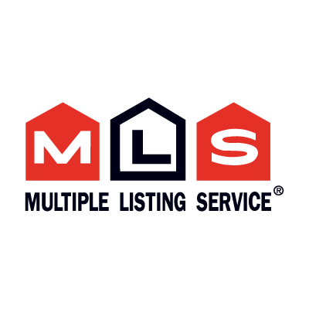

Burntwood

116 Hudson $139,000
54 Wekusko Street $158,900
46 Wekusko $180,000
47 Johnston Cres $229,000
63 Baffin Cres $249,000
47 Rankin Cres $250,000
20 Farrell Drive $349,900
170 Manasan Drive $369,000
194 Manasan Drive $479,900

Westwood

35 Partridge $173,900
31 Sandpiper Cres $184,000
48 Pike Cres $219,000
103 Sauger Cres $219,000
28 Pintail Cres $224,000
63 Rainbow Cres $239,000
72 Sauger Cres $239,000
172 Westwood Drive $239,500
23 Mallard $259,900
59 Rainbow Cres $265,000
331 Westwood Drive $269,900
28 Despins Road $348,000

Southwood

12 Confederation Cres. $185,000
14 Dominion $189,000
46 Oak Street $189,000
128 Centennial Drive W $298,500

PROPERTIES OFFERED FOR SALE
February 16, 2020

Maureen 204-679-0067
Tana 204-307-0236

Riverside

52 Silver Cres $229,500
60 Granite Cres $239,900

Deerwood

76 Deerwood Drive $140,000
44 Deerwood Drive $144,900
139 Greenway $155,000
64 Martin Bay $189,900

Juniper

47 Cypress Cres $109,000
16 Poplar Cres $124,000
23 Poplar Cres $154,999
246 Juniper $159,000
323 Juniper Drive $185,000

Eastwood

145 Brandon $ 80,000
197 Brandon Cres $ 92,000
118 Brandon Cres $ 94,500
108 Brandon Cres $ 99,900
6 Purdue Place $128,000
20 Harvard Cres $199,000
15 Oxford $199,000

Continued Over

Manasan Park

211 Campbell Road $134,900
79 Grass River $159,000
27 Robinson $168,000
11 Grass River $179,900
67 Robinson Way $179,750
61 Hargrave Bay $189,900
……..
Paint Lake

Block 2 Lot 14 Cottage Bay Road $455,000
Block 3 Lot 11 Cottage Bay Road $559,000

Liz Lake

Block 3 Lot 4 Lake View Drive $240,000
Block 3 Lot 17 Lake View $398,000
Block 8 Lot 2 Lake View Drive $374,900

Setting Lake

Road 1 Lot 33 $100,000
Road 3 Lot 24 $279,900

Commercial Properties

81 Hayes Road $115,000
185 Hayes Road $125,000
169 Hayes Road $225,000
60 Nelson Road $279,000
24 Station Road $299,000
200 Hayes Road $345,000
60 Crane Street $399,000
340 Juniper Drive $629,500
68 Crane Street $950,000

Our market is getting busier and we have Buyer’s looking for suitable homes for their families.
There is a shortage of homes that have been updated.
If you are thinking of selling – give one of us a call and we can discuss.

We always recommend using the MLS Service as this provides maximum exposure to our Sellers.

If you have an Exclusive Listing your house does not appear when Buyer’s are searching for homes to buy in Thompson – as they are not on Realtor.ca – the site where Buyer’s shop! This is especially important for out-of-town Buyer’s as they look on Realtor.ca – and do not know that there are Homes for Sale but are not on MLS…….

